DES-02: Database and Warehouse Design
System: UPHSL Credential Tracker (Online Academic Credential Request, Tracking and Monitoring)
Institution: University of Perpetual Help System, Office of the Registrar
Date: October 11, 2026

1. Database Technology
The system uses MySQL 8.4, a relational (SQL) database, with one database named uphsl_credential_tracker (character set utf8mb4).
A relational database fits this system for four reasons:
- The data is structured and strongly related: every request belongs to a student, a credential type and a college, and has ordered signing steps.
- Foreign keys keep the records consistent. A department, user or request that other records point to cannot be deleted.
- Transactions and row locks prevent two offices from signing the same step at the same time.
- Reports such as status counts, overdue requests and office workload are single SQL queries.
Data warehouse / feature storage. A separate warehouse is not needed. The data volume of one university registrar is small, so reports and derived features (DES-03) are computed directly from the operational tables with indexed SQL queries. For offline analysis, the registrar can export the request list as CSV.

2. Entities, Attributes and Keys
The database has 8 domain tables, plus Laravel's notifications table for the in-app notification bell. Table 1 lists each entity with its keys and main attributes.
Table 1. Entities and keys
Entity (table) | Purpose | Primary key | Foreign keys | Main attributes
departments | Colleges and offices that sign requests | id | - | name (unique), code (unique), type, description, is_active
users | Accounts of students, department staff and registrars | id | department_id → departments | first_name, middle_name, last_name, email (unique), role, is_active, password
credential_types | Documents that can be requested | id | - | name (unique), description, requires_payment, fee, processing_days, is_active
workflow_steps | Signing order of each credential type (set by the registrar) | id | credential_type_id → credential_types; department_id → departments | position, is_student_college, instructions
credential_requests | A student's request for a credential | id | user_id → users; credential_type_id → credential_types; college_id → departments | reference_no (unique), student_number, program, student_status, last_school_year, purpose, copies, requires_payment, fee, status, routed_at, due_at, ready_at, released_at
request_steps | The request's own copy of the signing order | id | credential_request_id → credential_requests; department_id → departments; acted_by → users | position, status, acted_at, remarks
payment_proofs | Receipts uploaded for paid credentials | id | credential_request_id → credential_requests; uploaded_by → users; reviewed_by → users | path, original_name, mime_type, size, reference_no, amount, status, remarks
request_events | Append-only ledger of every status change | id | credential_request_id → credential_requests; actor_id → users; request_step_id → request_steps; department_id → departments | type, from_status, to_status, remarks, created_at

3. Entity-Relationship Diagram
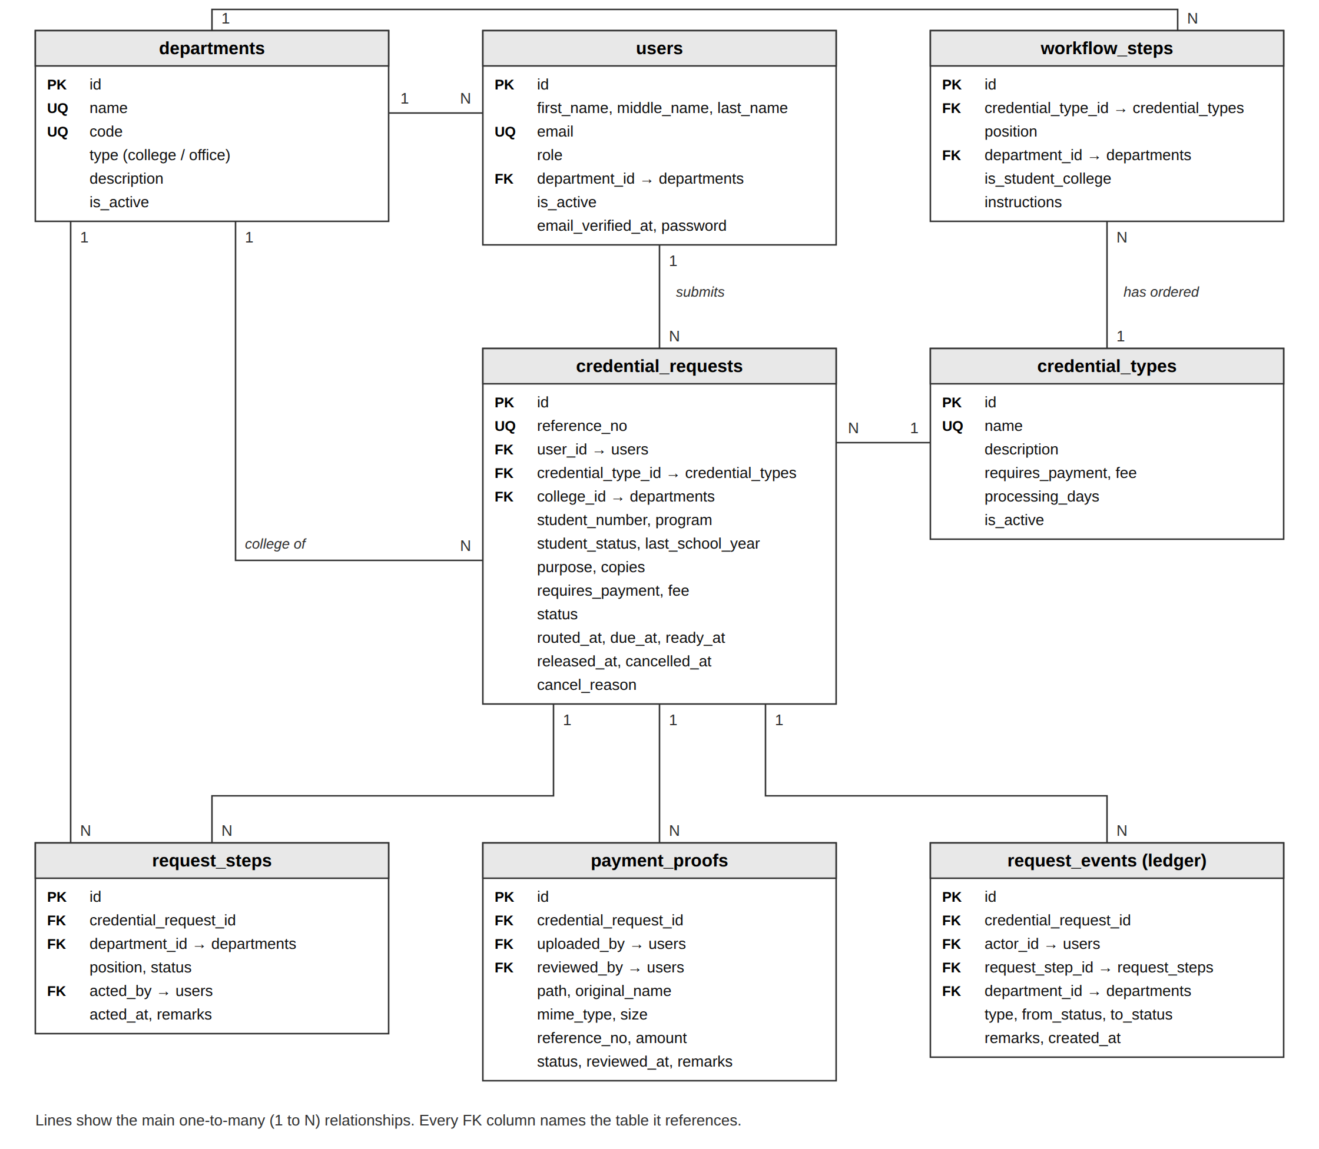
Figure 1. Entity-relationship diagram

4. Relationships
Table 2. Relationships between entities
Parent | Child | Cardinality | Foreign key | Meaning
departments | users | 1 to many | users.department_id | A department has many staff accounts (staff only).
users | credential_requests | 1 to many | credential_requests.user_id | A student submits many requests.
credential_types | credential_requests | 1 to many | credential_requests.credential_type_id | A credential type is requested many times.
departments | credential_requests | 1 to many | credential_requests.college_id | A college is the student's college on many requests.
credential_types | workflow_steps | 1 to many | workflow_steps.credential_type_id | A credential type has an ordered list of signing steps.
departments | workflow_steps | 1 to many (optional) | workflow_steps.department_id | Empty for the "Student's College" placeholder step.
credential_requests | request_steps | 1 to many | request_steps.credential_request_id | A routed request has one step per signing office.
departments | request_steps | 1 to many | request_steps.department_id | An office signs many request steps.
credential_requests | payment_proofs | 1 to many | payment_proofs.credential_request_id | Rejected receipts are kept, so a request can have several.
credential_requests | request_events | 1 to many | request_events.credential_request_id | Every change to a request adds one ledger row.
users | request_steps, payment_proofs, request_events | 1 to many | acted_by, uploaded_by, reviewed_by, actor_id | Records who signed, uploaded, reviewed or acted.
All foreign keys use ON DELETE RESTRICT, except workflow_steps, which are deleted together with their credential type. Requests, steps, receipts and ledger rows are never deleted.

5. SQL Implementation
The tables are created by Laravel migrations. The statements below are exported from the running database with SHOW CREATE TABLE (collation clauses removed for readability).

Table: departments
CREATE TABLE `departments` (
`id` bigint unsigned NOT NULL AUTO_INCREMENT,
`name` varchar(150) NOT NULL,
`code` varchar(20) NOT NULL,
`type` varchar(20) NOT NULL,
`description` varchar(255) DEFAULT NULL,
`is_active` tinyint(1) NOT NULL DEFAULT '1',
`created_at` timestamp NULL DEFAULT NULL,
`updated_at` timestamp NULL DEFAULT NULL,
PRIMARY KEY (`id`),
UNIQUE KEY `departments_name_unique` (`name`),
UNIQUE KEY `departments_code_unique` (`code`),
KEY `departments_type_index` (`type`),
KEY `departments_is_active_index` (`is_active`)
) ENGINE=InnoDB DEFAULT CHARSET=utf8mb4 COLLATE=utf8mb4_unicode_ci;

Table: users
CREATE TABLE `users` (
`id` bigint unsigned NOT NULL AUTO_INCREMENT,
`first_name` varchar(100) NOT NULL,
`middle_name` varchar(100) DEFAULT NULL,
`last_name` varchar(100) NOT NULL,
`email` varchar(255) NOT NULL,
`role` varchar(20) NOT NULL DEFAULT 'student',
`department_id` bigint unsigned DEFAULT NULL,
`is_active` tinyint(1) NOT NULL DEFAULT '1',
`email_verified_at` timestamp NULL DEFAULT NULL,
`password` varchar(255) NOT NULL,
`remember_token` varchar(100) DEFAULT NULL,
`created_at` timestamp NULL DEFAULT NULL,
`updated_at` timestamp NULL DEFAULT NULL,
PRIMARY KEY (`id`),
UNIQUE KEY `users_email_unique` (`email`),
KEY `users_role_index` (`role`),
KEY `users_department_id_foreign` (`department_id`),
CONSTRAINT `users_department_id_foreign` FOREIGN KEY (`department_id`) REFERENCES `departments` (`id`) ON DELETE RESTRICT
) ENGINE=InnoDB DEFAULT CHARSET=utf8mb4 COLLATE=utf8mb4_unicode_ci;

Table: credential_types
CREATE TABLE `credential_types` (
`id` bigint unsigned NOT NULL AUTO_INCREMENT,
`name` varchar(150) NOT NULL,
`description` text,
`requires_payment` tinyint(1) NOT NULL DEFAULT '0',
`fee` decimal(10,2) DEFAULT NULL,
`processing_days` tinyint unsigned NOT NULL DEFAULT '5',
`is_active` tinyint(1) NOT NULL DEFAULT '1',
`created_at` timestamp NULL DEFAULT NULL,
`updated_at` timestamp NULL DEFAULT NULL,
PRIMARY KEY (`id`),
UNIQUE KEY `credential_types_name_unique` (`name`),
KEY `credential_types_is_active_index` (`is_active`)
) ENGINE=InnoDB DEFAULT CHARSET=utf8mb4 COLLATE=utf8mb4_unicode_ci;

Table: workflow_steps
CREATE TABLE `workflow_steps` (
`id` bigint unsigned NOT NULL AUTO_INCREMENT,
`credential_type_id` bigint unsigned NOT NULL,
`position` smallint unsigned NOT NULL,
`department_id` bigint unsigned DEFAULT NULL,
`is_student_college` tinyint(1) NOT NULL DEFAULT '0',
`instructions` varchar(255) DEFAULT NULL,
`created_at` timestamp NULL DEFAULT NULL,
`updated_at` timestamp NULL DEFAULT NULL,
PRIMARY KEY (`id`),
KEY `workflow_steps_department_id_foreign` (`department_id`),
KEY `workflow_steps_credential_type_id_position_index` (`credential_type_id`,`position`),
CONSTRAINT `workflow_steps_credential_type_id_foreign` FOREIGN KEY (`credential_type_id`) REFERENCES `credential_types` (`id`) ON DELETE CASCADE,
CONSTRAINT `workflow_steps_department_id_foreign` FOREIGN KEY (`department_id`) REFERENCES `departments` (`id`) ON DELETE RESTRICT
) ENGINE=InnoDB DEFAULT CHARSET=utf8mb4 COLLATE=utf8mb4_unicode_ci;

Table: credential_requests
CREATE TABLE `credential_requests` (
`id` bigint unsigned NOT NULL AUTO_INCREMENT,
`reference_no` varchar(20) DEFAULT NULL,
`user_id` bigint unsigned NOT NULL,
`credential_type_id` bigint unsigned NOT NULL,
`college_id` bigint unsigned NOT NULL,
`student_number` varchar(30) NOT NULL,
`program` varchar(150) NOT NULL,
`student_status` varchar(10) NOT NULL,
`last_school_year` varchar(9) NOT NULL,
`purpose` varchar(500) NOT NULL,
`copies` tinyint unsigned NOT NULL DEFAULT '1',
`requires_payment` tinyint(1) NOT NULL,
`fee` decimal(10,2) DEFAULT NULL,
`status` varchar(30) NOT NULL,
`routed_at` timestamp NULL DEFAULT NULL,
`due_at` timestamp NULL DEFAULT NULL,
`ready_at` timestamp NULL DEFAULT NULL,
`released_at` timestamp NULL DEFAULT NULL,
`cancelled_at` timestamp NULL DEFAULT NULL,
`cancel_reason` varchar(500) DEFAULT NULL,
`created_at` timestamp NULL DEFAULT NULL,
`updated_at` timestamp NULL DEFAULT NULL,
PRIMARY KEY (`id`),
UNIQUE KEY `credential_requests_reference_no_unique` (`reference_no`),
KEY `credential_requests_credential_type_id_foreign` (`credential_type_id`),
KEY `credential_requests_college_id_foreign` (`college_id`),
KEY `credential_requests_status_created_at_index` (`status`,`created_at`),
KEY `credential_requests_user_id_created_at_index` (`user_id`,`created_at`),
KEY `credential_requests_status_due_at_index` (`status`,`due_at`),
CONSTRAINT `credential_requests_college_id_foreign` FOREIGN KEY (`college_id`) REFERENCES `departments` (`id`) ON DELETE RESTRICT,
CONSTRAINT `credential_requests_credential_type_id_foreign` FOREIGN KEY (`credential_type_id`) REFERENCES `credential_types` (`id`) ON DELETE RESTRICT,
CONSTRAINT `credential_requests_user_id_foreign` FOREIGN KEY (`user_id`) REFERENCES `users` (`id`) ON DELETE RESTRICT
) ENGINE=InnoDB DEFAULT CHARSET=utf8mb4 COLLATE=utf8mb4_unicode_ci;

Table: request_steps
CREATE TABLE `request_steps` (
`id` bigint unsigned NOT NULL AUTO_INCREMENT,
`credential_request_id` bigint unsigned NOT NULL,
`position` smallint unsigned NOT NULL,
`department_id` bigint unsigned NOT NULL,
`instructions` varchar(255) DEFAULT NULL,
`status` varchar(20) NOT NULL,
`acted_by` bigint unsigned DEFAULT NULL,
`acted_at` timestamp NULL DEFAULT NULL,
`remarks` varchar(500) DEFAULT NULL,
`created_at` timestamp NULL DEFAULT NULL,
`updated_at` timestamp NULL DEFAULT NULL,
PRIMARY KEY (`id`),
KEY `request_steps_acted_by_foreign` (`acted_by`),
KEY `request_steps_credential_request_id_position_index` (`credential_request_id`,`position`),
KEY `request_steps_department_id_status_index` (`department_id`,`status`),
CONSTRAINT `request_steps_acted_by_foreign` FOREIGN KEY (`acted_by`) REFERENCES `users` (`id`) ON DELETE RESTRICT,
CONSTRAINT `request_steps_credential_request_id_foreign` FOREIGN KEY (`credential_request_id`) REFERENCES `credential_requests` (`id`) ON DELETE RESTRICT,
CONSTRAINT `request_steps_department_id_foreign` FOREIGN KEY (`department_id`) REFERENCES `departments` (`id`) ON DELETE RESTRICT
) ENGINE=InnoDB DEFAULT CHARSET=utf8mb4 COLLATE=utf8mb4_unicode_ci;

Table: payment_proofs
CREATE TABLE `payment_proofs` (
`id` bigint unsigned NOT NULL AUTO_INCREMENT,
`credential_request_id` bigint unsigned NOT NULL,
`uploaded_by` bigint unsigned NOT NULL,
`path` varchar(255) NOT NULL,
`original_name` varchar(255) NOT NULL,
`mime_type` varchar(100) NOT NULL,
`size` int unsigned NOT NULL,
`reference_no` varchar(100) DEFAULT NULL,
`amount` decimal(10,2) DEFAULT NULL,
`status` varchar(20) NOT NULL,
`reviewed_by` bigint unsigned DEFAULT NULL,
`reviewed_at` timestamp NULL DEFAULT NULL,
`remarks` varchar(500) DEFAULT NULL,
`created_at` timestamp NULL DEFAULT NULL,
`updated_at` timestamp NULL DEFAULT NULL,
PRIMARY KEY (`id`),
KEY `payment_proofs_credential_request_id_foreign` (`credential_request_id`),
KEY `payment_proofs_uploaded_by_foreign` (`uploaded_by`),
KEY `payment_proofs_reviewed_by_foreign` (`reviewed_by`),
KEY `payment_proofs_status_index` (`status`),
CONSTRAINT `payment_proofs_credential_request_id_foreign` FOREIGN KEY (`credential_request_id`) REFERENCES `credential_requests` (`id`) ON DELETE RESTRICT,
CONSTRAINT `payment_proofs_reviewed_by_foreign` FOREIGN KEY (`reviewed_by`) REFERENCES `users` (`id`) ON DELETE RESTRICT,
CONSTRAINT `payment_proofs_uploaded_by_foreign` FOREIGN KEY (`uploaded_by`) REFERENCES `users` (`id`) ON DELETE RESTRICT
) ENGINE=InnoDB DEFAULT CHARSET=utf8mb4 COLLATE=utf8mb4_unicode_ci;

Table: request_events
CREATE TABLE `request_events` (
`id` bigint unsigned NOT NULL AUTO_INCREMENT,
`credential_request_id` bigint unsigned NOT NULL,
`actor_id` bigint unsigned DEFAULT NULL,
`type` varchar(30) NOT NULL,
`from_status` varchar(30) DEFAULT NULL,
`to_status` varchar(30) DEFAULT NULL,
`request_step_id` bigint unsigned DEFAULT NULL,
`department_id` bigint unsigned DEFAULT NULL,
`remarks` text,
`created_at` timestamp NOT NULL DEFAULT CURRENT_TIMESTAMP,
PRIMARY KEY (`id`),
KEY `request_events_actor_id_foreign` (`actor_id`),
KEY `request_events_request_step_id_foreign` (`request_step_id`),
KEY `request_events_department_id_foreign` (`department_id`),
KEY `request_events_credential_request_id_id_index` (`credential_request_id`,`id`),
CONSTRAINT `request_events_actor_id_foreign` FOREIGN KEY (`actor_id`) REFERENCES `users` (`id`) ON DELETE RESTRICT,
CONSTRAINT `request_events_credential_request_id_foreign` FOREIGN KEY (`credential_request_id`) REFERENCES `credential_requests` (`id`) ON DELETE RESTRICT,
CONSTRAINT `request_events_department_id_foreign` FOREIGN KEY (`department_id`) REFERENCES `departments` (`id`) ON DELETE RESTRICT,
CONSTRAINT `request_events_request_step_id_foreign` FOREIGN KEY (`request_step_id`) REFERENCES `request_steps` (`id`) ON DELETE RESTRICT
) ENGINE=InnoDB DEFAULT CHARSET=utf8mb4 COLLATE=utf8mb4_unicode_ci;

6. Sample Records
The records below are demo data loaded by the system's DemoSeeder. Password hashes are shortened.

6.1 departments
SELECT id, name, code, type, is_active FROM departments ORDER BY id LIMIT 5;
id | name | code | type | is_active
1 | College of Arts and Sciences | CAS | college | 1
2 | College of Business and Accountancy | CBA | college | 1
3 | College of Computer Studies | CCS | college | 1
4 | College of Criminology | CRIM | college | 1
5 | College of Education | COED | college | 1

6.2 credential_types
SELECT id, name, requires_payment, processing_days, is_active FROM credential_types ORDER BY id LIMIT 5;
id | name | requires_payment | processing_days | is_active
1 | Transcript of Records | 1 | 10 | 1
2 | Certificate of Enrollment | 0 | 3 | 1
3 | Certificate of Grades | 0 | 5 | 1
4 | Good Moral Certificate | 0 | 5 | 1
5 | Honorable Dismissal / Transfer Credentials | 1 | 10 | 1

6.3 workflow_steps (Transcript of Records)
SELECT id, credential_type_id, position, department_id, is_student_college FROM workflow_steps WHERE credential_type_id = 1 ORDER BY position;
id | credential_type_id | position | department_id | is_student_college
1 | 1 | 1 | 12 | 0
2 | 1 | 2 | 13 | 0
3 | 1 | 3 | NULL | 1
4 | 1 | 4 | 15 | 0

6.4 credential_requests
SELECT id, reference_no, user_id, credential_type_id, college_id, copies, status, due_at FROM credential_requests ORDER BY id LIMIT 5;
id | reference_no | user_id | credential_type_id | college_id | copies | status | due_at
1 | CR-2026-000001 | 17 | 1 | 3 | 2 | awaiting_payment | NULL
2 | CR-2026-000002 | 18 | 1 | 2 | 1 | payment_review | NULL
3 | CR-2026-000003 | 20 | 2 | 5 | 2 | registrar_review | NULL
4 | CR-2026-000004 | 19 | 1 | 6 | 1 | in_progress | 2026-10-21 12:13:00
5 | CR-2026-000005 | 17 | 1 | 3 | 1 | in_progress | 2026-10-19 12:55:00

6.5 request_steps
SELECT id, credential_request_id, position, department_id, status, acted_by, remarks FROM request_steps WHERE credential_request_id = 6 ORDER BY position;
id | credential_request_id | position | department_id | status | acted_by | remarks
9 | 6 | 1 | 12 | signed | 13 | No accountabilities.
10 | 6 | 2 | 13 | pending | NULL | NULL
11 | 6 | 3 | 5 | waiting | NULL | NULL
12 | 6 | 4 | 15 | waiting | NULL | NULL

6.6 payment_proofs
SELECT id, credential_request_id, original_name, mime_type, amount, status, reviewed_by FROM payment_proofs ORDER BY id LIMIT 4;
id | credential_request_id | original_name | mime_type | amount | status | reviewed_by
1 | 2 | receipt.png | image/png | 300.00 | submitted | NULL
2 | 4 | receipt.png | image/png | 300.00 | accepted | 1
3 | 5 | receipt.png | image/png | 300.00 | accepted | 1
4 | 6 | receipt.png | image/png | 300.00 | accepted | 1

7. Sample Queries
Each query below was run on the database; the results shown are its actual output.

Query 1. All users
SELECT id, first_name, last_name, email, role, department_id, is_active, LEFT(password, 7) AS password FROM users ORDER BY id LIMIT 5;
The rubric asks for SELECT * FROM users. The full result has 13 columns, so the main columns are shown here and password hashes are cut to their first 7 characters.
id | first_name | last_name | email | role | department_id | is_active | password
1 | Office of the | Registrar | registrar@uphsl.edu.ph | registrar | NULL | 1 | $2y$12$
2 | CAS | Staff | cas@uphsl.edu.ph | department | 1 | 1 | $2y$12$
3 | CBA | Staff | cba@uphsl.edu.ph | department | 2 | 1 | $2y$12$
4 | CCS | Staff | ccs@uphsl.edu.ph | department | 3 | 1 | $2y$12$
5 | CRIM | Staff | crim@uphsl.edu.ph | department | 4 | 1 | $2y$12$

Query 2. System output (in place of a predictions table)
SELECT reference_no, status, routed_at, due_at, ready_at, released_at FROM credential_requests ORDER BY id;
This system has no predictions table because it does not use a machine-learning model. Its output is the status and dates of each request, which this query returns.
reference_no | status | routed_at | due_at | ready_at | released_at
CR-2026-000001 | awaiting_payment | NULL | NULL | NULL | NULL
CR-2026-000002 | payment_review | NULL | NULL | NULL | NULL
CR-2026-000003 | registrar_review | NULL | NULL | NULL | NULL
CR-2026-000004 | in_progress | 2026-10-07 12:13:00 | 2026-10-21 12:13:00 | NULL | NULL
CR-2026-000005 | in_progress | 2026-10-05 12:55:00 | 2026-10-19 12:55:00 | NULL | NULL
CR-2026-000006 | in_progress | 2026-09-20 15:43:00 | 2026-10-02 15:43:00 | NULL | NULL
CR-2026-000007 | in_progress | 2026-10-09 14:47:00 | 2026-10-16 14:47:00 | NULL | NULL
CR-2026-000008 | ready_for_release | 2026-10-02 11:55:00 | 2026-10-09 11:55:00 | 2026-10-03 10:55:00 | NULL
CR-2026-000009 | released | 2026-09-27 12:18:00 | 2026-09-30 12:18:00 | 2026-09-28 03:18:00 | 2026-09-28 03:18:00
CR-2026-000010 | cancelled | NULL | NULL | NULL | NULL

Query 3. Where each in-progress document is now
SELECT r.reference_no, t.name AS credential, d.name AS currently_at, s.status AS step_status
FROM credential_requests r
JOIN credential_types t ON t.id = r.credential_type_id
JOIN request_steps s ON s.credential_request_id = r.id AND s.status IN ('pending', 'on_hold')
JOIN departments d ON d.id = s.department_id
WHERE r.status = 'in_progress'
ORDER BY r.reference_no;
reference_no | credential | currently_at | step_status
CR-2026-000004 | Transcript of Records | Library | on_hold
CR-2026-000005 | Transcript of Records | College of Computer Studies | pending
CR-2026-000006 | Transcript of Records | Cashier / Finance Office | pending
CR-2026-000007 | Good Moral Certificate | Student Affairs / Student Personnel Services | pending

Query 4. Number of requests per status
SELECT status, COUNT(*) AS total FROM credential_requests GROUP BY status ORDER BY total DESC, status;
status | total
in_progress | 4
awaiting_payment | 1
cancelled | 1
payment_review | 1
ready_for_release | 1
registrar_review | 1
released | 1

Query 5. Overdue requests
SELECT reference_no, due_at, DATEDIFF(NOW(), due_at) AS days_overdue
FROM credential_requests
WHERE status = 'in_progress' AND due_at < NOW()
ORDER BY due_at;
reference_no | due_at | days_overdue
CR-2026-000006 | 2026-10-02 15:43:00 | 9

Query 6. Ledger (tracking history) of one request
SELECT e.created_at, e.type, d.code AS office, e.remarks
FROM request_events e
LEFT JOIN departments d ON d.id = e.department_id
WHERE e.credential_request_id = 4
ORDER BY e.id;
created_at | type | office | remarks
2026-10-07 12:13:00 | submitted | NULL | NULL
2026-10-07 12:13:00 | payment_submitted | NULL | NULL
2026-10-07 12:13:00 | payment_accepted | NULL | NULL
2026-10-07 12:13:00 | routed | NULL | Verified.
2026-10-07 12:13:00 | step_held | LIB | Unreturned book: Engineering Mechanics (Hibbeler).

